**SPH3U 8.2 Types of Mechanical Waves**

1. **Types of waves**

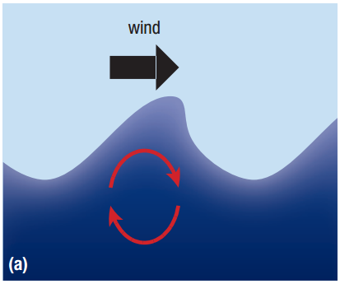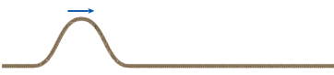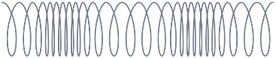

|  |  |
| --- | --- |
| Transverse wave: |  |
| Longitudinal wave: |  |
| waves in gases |  |
| sound |  |
| complex wave motion |  |

**Homework:** page 384: #2-4